**SenseBoard – Theremin Project**

**You will be constructing a Theremin using the SenseBoard. A Theremin is a device that can allow you to change features of a song or tune by using sensors to detect how much change a tune will be. In this example, you will be using a light sensor to change the pitch of a repeating tune.**

**Constructing the Theremin**

**You will need:**

* A working SenseBoard.
* A Lamp or other light-emitting device.
* (Optional) A dark room

**Method:**

1. In the ‘Sensors and infrared LED’ box within your SenseBoard Package and take out the light sensor, which is the green-taped cable. Connect the light sensor to one of the inputs. If necessary, you can use the extension cable found in the ‘Cables’ box to lengthen the sensor.
2. Take out the stepper motor from its corresponding box and connect it to the ‘Motors’ slot on the SenseBoard.
3. Connect a lamp to power supply and place it where your sensor can reach the lamp.

**Now you have a working area to test your Theremin. Next you will need to start programming your SenseBoard with Sense.**

**Sense Programming**

**You will need:**

* **Sense**
* **Connected Senseboard to Computer**

**Method:**

When you open up Sense, don’t be confused on what each thing does, follow the instructions below and you will have working a Theremin.

On Sense, in the middle-top, there is a button called ‘Extras’, click on it and select ‘Show SenseBoard Watcher’ in the drop-down menu. On the white screen to the right there should be a box containing information about values of different inputs.

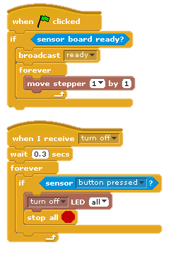Firstly, click the control tab found on the left-hand side of Sense. Replicate this coding by dragging the corresponding functions and attaching them to each other. These functions are found in ‘Control’, ‘Inputs’ and ‘Outputs’ tabs.

The broadcast function allows you to activate another block when it receives the term. For example when this block is activated, it will broadcast the term ‘ready’, another block can receive this term and will activate itself

Press the green flag found on the top of your screen to test the block out.

This block will detect if the SenseBoard is working and functional by moving the motor. It will also broadcast the term ‘ready’ which will activate a different block.

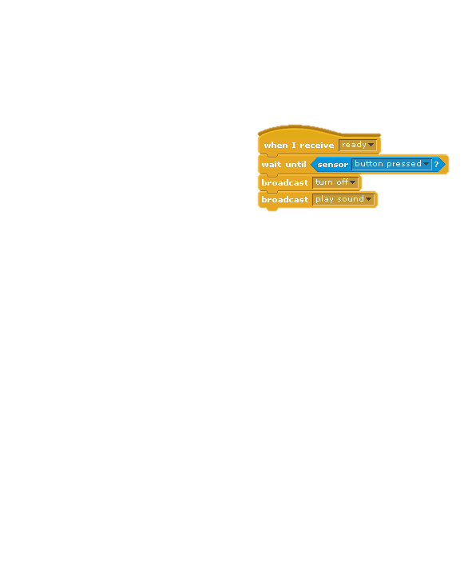The next block you should create is shown on the right. These blocks are found in ‘Control’ and ‘Inputs’ tabs.

This block will receive the ‘ready’ term from the first block and then will wait until the button is pressed to continue the block. When button is pressed, it will broadcast two other terms, ‘turn off’ and ‘play sound’.

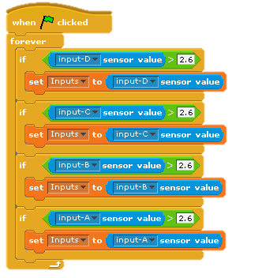These command blocks can be found in ‘Control’, ‘Inputs’, ‘Operators’ and ‘Variables’

Variables are changeable values that are recorded in memory. In this example, a variable is used to change to combine all four inputs so that only one is used for the Theremin. Variables can be created in the ‘Variables’ tab.

Create a variable called ‘Inputs’ and set it globally if given the option. Then construct this block using the variable.

This block will detect the light sensor input number. The reason why the number 2.6 is used because when there are no inputs on the SenseBoard, there is a stationary sensor value of 2.4 or 2.5 on each input. A value higher than those two will mean that there is a sensor inserted.

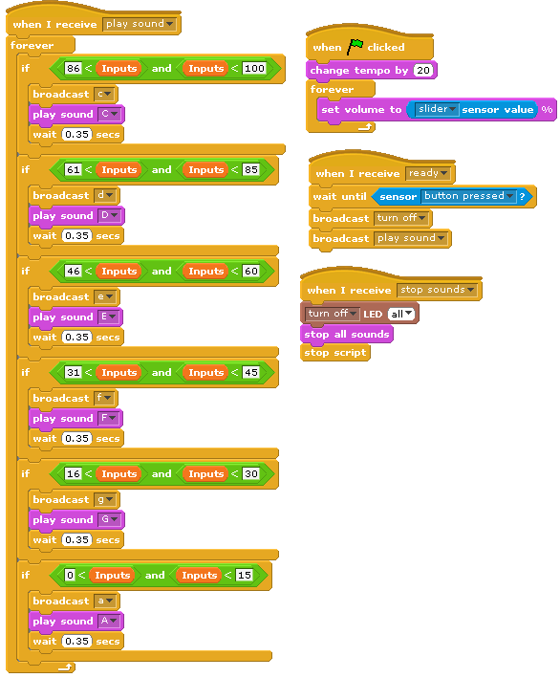

These command blocks can be found in ‘Control’, ‘Operators’, ‘Sound’ and ‘Variables’

This is probably the most important block for the Theremin programming. This block will play different sounds in a certain boundary as set in the variable ‘Inputs’. When the variable meets a certain boundary it will a play sound and then will wait 0.35 seconds then play the same sound again unless the sensor is moved to different lighting.

This block is set so that in darker locations it will play the C note and in brighter locations, it will play the A note.

You may wish to change the boundaries by changing the numbers in the operators if reaching certain values is an issue.

The broadcast command in this block will be used on the different command block, however including this broadcast functions is optional.

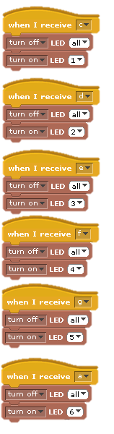These command blocks can be found in ‘Control’ and ‘Outputs’.

These blocks are used to turn on LEDs on the SenseBoard. There are 6 LEDs on the SenseBoard and will light up relative what note is playing. For example, when a C note is played, any LED that is turned on from other notes is turned off and then a LED light is turned on to represent the C note playing. Each note has its own LED light.

However these are purely for visual effects and have no effect on the Theremin.